**Appendix A. Broadband regulatory framework**

The United States primarily deploys a private model of broadband service provision.[1] Broadband service is generally provided by telephone and cable companies, both of which upgraded their traditional voice and video networks, respectively, to offer data services. These broadband service providers (BSPs) invest significant capital in constructing, operating, and maintaining a large network of cables and facilities that house data centers, servers, and routers. Since these key components of broadband infrastructure must be integrated into the existing built environment, the providers need access to poles, ducts, and conduits, as well as the rights-of-way (both public and private) within which their broadband infrastructure can be housed. Once the physical infrastructure is in place, BSPs also must adhere to policies regulating the provision of services. This process of accessing and obtaining permission to use existing facilities, construct new infrastructure, and provide internet services is governed by a multitude of federal, state, and local policies.

This appendix summarizes the major features of broadband regulation policy at the federal level.

***Wireline broadband infrastructure: Who regulates what?***

There are three primary modes of wireline broadband provision today: digital subscriber line (DSL), cable, and fiber optic cable. All these modes require the construction, operation, and maintenance of a physical cable network. DSL uses phone lines to provide broadband service, while cable companies transmit digital data over cable television lines. Fiber optic cable, a newer and faster technology, contains strands of glass fibers inside an insulated casing. The deployment of fiber optic cable is still in its infancy in the United States, making DSL and cable broadband the dominant modes of internet service provision. [2] It is important to note that cable broadband companies can update their infrastructure capabilities without retrenching their networks, while DSL providers would need to do so.

The network for these three modes can be constructed in three primary ways: *underground installation*, where cables are placed in conduits that are then buried; *buried installation*, where cables (with or without protective ducts) are directly buried in the ground; and *aerial installation*, where cables are attached to existing utility poles. Trenches for underground or buried cable are most commonly dug alongside existing infrastructure networks, such as highways and roadways. Cables may also require supporting infrastructure such as pedestals, manholes, and controlled-environment vaults. The installation of the network and its associated components thus requires permission (most often from city or local governments) to access and modify the existing built environment.

The top half of Figure A1 depicts the typical pathway for broadband service provision, while the bottom half points to key regulatory policies at the federal, state and local levels that govern important points along the pathway. The top half of the figure illustrates the key components of physical infrastructure for wireline broadband provision, from the backbone to the end user. The Internet relies on a backbone to carry data over long distances. The backbone consists of several ultra-high bandwidth connections that link together at key network nodes all over the world. Next, an Internet Exchange Point (IXP) facilitates the costless/low-cost exchange of internet traffic between different provider networks through mutual peering agreements. Finally, at a point of presence (PoP), a long-distance carrier’s cables typically end and connect into a local regional or city network. From the point of presence, internet traffic is routed to the end user.

**Figure A1: Fixed broadband infrastructure system in the United States**

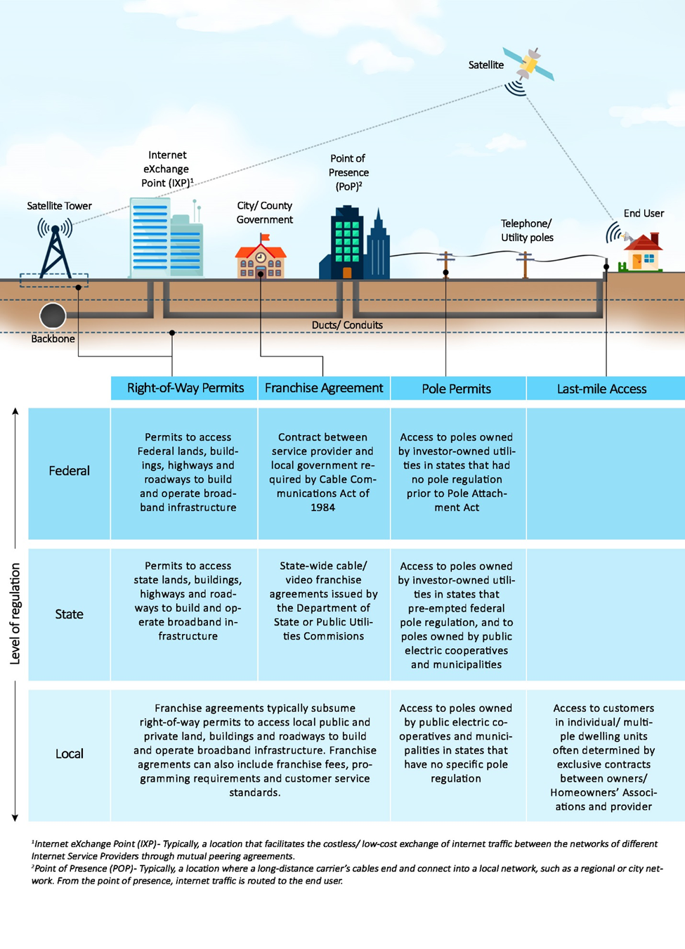

*Source: Brookings Institution.*

***Rights-of-way***

Rights-of-way permits determine access to the public transportation and utility corridors as well as the private land required to build a broadband network. These permits are typically part of franchise agreements with local governments. However, governments at all levels may exhibit regulatory authority, including federal, state, local, and even tribal governments.[3] For instance, the United States Department of Transportation (DOT) governs access to federally assisted highways. Below the federal level, rights-of-way policy is often inconsistent between different states and cities. To add to the complexity, rights-of-way are also used by other utilities, including electricity, water, and gas.

In 2012, President Obama signed an executive order to facilitate broadband deployment on federal lands, buildings, rights-of-way, federally assisted highways, and tribal lands.[4] The order created an interagency working group composed of a number of federal agencies, including DOT, with a goal to reduce barriers to the expansion of broadband services in underserved communities. The order directed the Federal Highway Administration to review “dig once” requirements in existing programs, in order to coordinate the placement of underground fiber optic cable along highway and roadway rights-of-way. The order also includes provisions such as imposing a moratorium on street excavation to preserve new roadways, installation of empty conduit in the right-of-way during new construction, and the use of trenchless technologies, such as horizontal directional drilling or micro-trenching.[5]

***Franchise agreements***

The Cable Communications Act of 1984 requires city, county, and state governments and cable television providers who offer internet service to sign a contract known as a franchise agreement. Before any service provider can install infrastructure, governments typically request bids from companies that wish to provide service. The bid process is followed by a franchise negotiation and the signing of a contract between the government and the provider that is typically renewed every 10 years. Note that local franchise requirements legally apply only to cable television companies, but today, internet, television, and voice (telephone) provision are often bundled into a single package. This can bring internet service providers under the purview of these agreements.

A franchise agreement is a contract that typically covers rights to access public and private rights-of-way, to construct and operate infrastructure, and to provide customer service. It can also include service standards, franchise fees of up to 5 percent of the provider’s gross revenue, and provision of public, educational, and government programming. Critically, those standards can mandate ubiquitous service to all neighborhoods within a service territory. However, the agreements cannot determine the price of services.[6]

The questions of how easy it is to negotiate with governments and how willing governments are to make concessions often play a key role in broadband deployment. According to the Government Accountability Office, providers can be sensitive to how receptive state and local government officials are to new market entrants.[7] They specifically consider the degree to which state and local government officials make efforts to reduce administrative requirements that pose significant barriers to entry. More recently, when telecommunications companies started providing video services, a large number of states changed the law to allow for statewide franchising.[8]

***Poles, ducts, and conduit access***

There are roughly 134 million poles in the United States owned by various entities, including private investors and public agencies such as electric utilities and municipalities.[9] Access to poles, ducts, and conduits is often crucial for attaching cables/wires to existing poles or future small cell facilities. Under the federal Pole Attachment Act, as amended by the Telecommunications Act of 1996,[10] the procedure for applying for the right to access poles varies by whether the utilities are investor-owned or owned by public electric cooperatives or municipalities. When poles are owned by investor-owned utilities, there can be one of two situations:

* States whose investor-owned utilities are regulated by the Federal Communications Commission (FCC) for pole attachment purposes; or
* States whose investor-owned utilities are regulated by the states themselves as the states have preempted federal regulation of pole attachments.

The 1996 act exempts public electric cooperatives and municipalities from any federal pole regulation, and it is therefore left to the states to decide how to regulate them. Some states have state-level regulation in place, while some don’t, in which case the BSPs have to negotiate with individual cooperatives and municipalities. This can be an expensive and time-consuming process.

In recognition of the barrier posed to timely and cost-efficient broadband provision by the lack of access to poles at reasonable rates and conditions, the FCC has tried to simplify and hasten the process. In 2010, the FCC’s National Broadband Plan recommended the establishment of rental rates for pole attachments that are as low and uniform as possible to promote broadband deployment. In 2011, the FCC issued the Pole Attachments Order to streamline access to utility poles across the country.[11] State legislatures, too, have been under pressure to create consistent and favorable rules for pole attachments.

Pole access and related policies will only continue to gain interest from BSPs and governments in the coming years as emerging technologies like 5G require new pole infrastructure.

***Last-mile access***

Homeowner associations and managers of buildings, especially apartments classified as multiple tenant environments, often have exclusive contracts with incumbent cable operators to provide broadband to their residents. These agreements can pose a problem to new BSPs trying to use the existing infrastructure within the buildings to provide service, as well as a problem to new or existing BSPs seeking to install new technologies such as fiber. In response to this issue, the FCC released a Notice of Inquiry in June 2017 seeking comment on the need to reduce barriers faced by broadband providers that are serving or want to serve multiple tenant environments.[12]

***Broadband service provider limitations***

While the vast majority of BSPs are privately owned, there are publicly owned broadband service providers in many communities. Laws in some states prevent local governments from building public broadband networks, also called municipal broadband. These limitations can extend to entire networks, or might stop publicly built networks from connecting to end users. This highly contentious and important topic is beyond the scope of this paper.

1. There are important exceptions, including community-owned broadband networks in places like Chattanooga, Tenn. and Wilson, N.C.
2. One significant difference between telecom and cable companies is that telecom companies have to re-trench in order to upgrade from DSL to fiber optic, whereas cable companies can upgrade their existing network without re-trenching.
3. Scott Walsten, “Broadband Penetration: An Empirical Analysis of State and Federal Policies” (Washington: American Enterprise Institute-Brookings Joint Center for Policy Studies, Working Paper 05-12, 2005.
4. “Accelerating Broadband Infrastructure Deployment,” <https://obamawhitehouse.archives.gov/the-press-office/2012/06/14/executive-order-accelerating-broadband-infrastructure-deployment>.
5. “Minimizing Excavation Through Coordination,” Federal Highway Administration, Office of Transportation Policy Studies, October 2013, <https://www.fhwa.dot.gov/policy/otps/policy_brief_dig_once.pdf>.
6. Historically, local communications infrastructure depended on telephone networks that were owned and operated by large companies that serviced areas that were larger than any one single neighborhood or community. This meant that the telephone companies were regulated as “common carriers” by state public utility commissions and the FCC, and not by local governments. Federal law thus prohibits local governments from regulating cable rates, except for the lowest-cost tier of service.
7. “Broadband Deployment Is Extensive Throughout the United States, But It Is Difficult to Assess the Extent of Deployment Gaps in Rural Areas,” U.S. Government Accountability Office, GAO-06-426, 2006.
8. “Statewide Video Franchising Status,” National Conference of State Legislatures, 2014, <http://www.ncsl.org/research/telecommunications-and-information-technology/statewide-video-franchising-statutes.aspx>.
9. FCC.
10. Jill M. Valenstein, “Communications Attacher Efforts Lead to Laws Governing Pole Owning Electric Cooperatives and Municipalities,” *Broadband Deployment Law Advisor,* 2013, <http://www.broadbandlawadvisor.com/2013/05/articles/infrastructure-poles-conduit-and-rights-of-way/communications-attacher-efforts-lead-to-laws-governing-pole-owning-electric-cooperatives-and-municipalities/>.
11. FCC Order 11-50, 2011.
12. “Improving Competitive Broadband Access to Multiple Tenant Environments,” FCC Fact Sheet, 2017, <http://transition.fcc.gov/Daily_Releases/Daily_Business/2017/db0601/DOC-345161A1.pdf>.